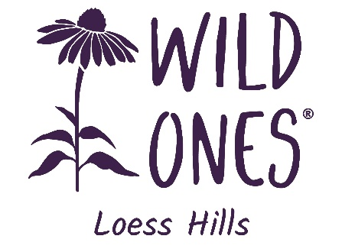
March 21, 2024

We appreciate your interest in applying for a Native Plant Grant from Loess Hills Wild Ones for nonprofit organizations. We are excited by the possibility of helping you incorporate native plants into the Siouxland region!
Grant awards of $400.00 and 1 flat of plants (32 plants) from our Spring 2024 plant sale will be awarded. Nonprofit organizations within a 75-mile radius of Sioux City, IA, are eligible for this grant. The grant is intended to provide your organization with a way of preparing, planting, and maintaining an area of natural landscaping with native plants. Projects with an educational aspect, like a small butterfly garden, a little prairie area, or landscaping near a school or public building, would be ideal.
Please fill in the entire grant application to the best of your ability. The questions are designed to get you to think about and plan for all aspects of the project; the application is evaluated in its entirety. All grant applications are due by April 30, 2024.
If you have any questions, please get in touch with us at loesshillswildones@gmail.com and include the word “Grant” in the subject line.
Grants will be awarded on May 17, at 5:00 p.m., at our Spring 2024 Plant Sale at the home of our Co-Vice Presidents, Tom and Cheri Stewart, at 2801 S. Cecelia Street in Sioux City. We look forward to reviewing your application, and we are excited about the possibilities of more native plants in our area.

Sincerely,
Loess Hills Wild Ones

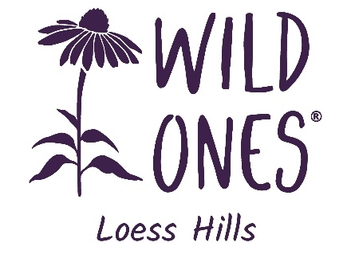
NONPROFIT GRANT APPLICATION
SPRING 2024
Complete this form, save it as a new file on your computer, and attach this file to an email, as noted below.
Instructions
- Read the introductory letter to understand the awards process and eligibility requirements.
- Grant awards of $400.00 and 1 flat of plants (32 plants) from our 2024 Spring Native Plant Sale on May 17. will be awarded.
- Complete all sections of the Grant Application Form. These questions are designed to get individuals to think about and plan for all aspects of the project; the application is evaluated in its entirety.
- After completing this form, attach it to an email message addressed to loesshillswildones@gmail.com, noting “Grant Application” in the subject line. You can also print out a blank copy of the application, fill it in by hand, and mail it to LHWO Grant Committee, 3301 Walden Ave., Sioux City, IA 51106.
- If you have questions or need further information, please email loesshillswildones@gmail.com and include “Grant” in the subject line.
- All grant applications are due by April 30, 2024.
Name of Contact Person: Click or tap here to enter text.
Name Nonprofit Group: Click or tap here to enter text.
E‐mail Address: Click or tap here to enter text.
Project Location: Click or tap here to enter text.
Project Description
Please answer the following questions in one or two sentences:
- What are the short- and long-term goals of the project?
Click or tap here to enter text.
- To what extent will the project achieve one or more of the following objectives:
  - Restore or develop the native plant community.
  - Provide habitat for native wildlife.
  - Educate others about the beauty and significance of native ecosystems.
Click or tap here to enter text.

- What groups and organizations will be involved in developing and maintaining this project? What are the ages of the students or children involved? (If applicable)
Click or tap here to enter text.

- Who owns the project site? Describe their commitment to the project.
Click or tap here to enter text.

- What other funding will be used to develop and maintain this project?
Click or tap here to enter text.

- How will long-term maintenance be assured?
Click or tap here to enter text.
- Are there any invasive species on or near the site? If so, how do you plan to address them?
Click or tap here to enter text.
- Describe the Project Location: What is the soil/ground like? How much sun does it get (hours/day, morning only, all day, etc.)? How moist does the soil get/remain after rain? What are the approximate dimensions?
Click or tap here to enter text.
- Please attach a photo and/or drawing of the project site. Files are restricted to 1 MB. (PDF or various image file types, five images max)
Click or tap here to enter text.
- Please include a preliminary list of species you plan to plant. List scientific and common names, the number of plants, and an estimate of the cost. (Estimate 1 plant per square foot to get total numbers.)
Click or tap here to enter text.

- How did you choose the plants for this site? Did you have assistance?
Click or tap here to enter text.

- What is your planned timetable, including planting date(s)?
Click or tap here to enter text.

- Have you raised other funds for this project? Are other organizations contributing, and will they be listed as co-sponsors?
Click or tap here to enter text.
- What will the site be used for besides supporting wildlife and pollinators? (i.e., Meetings, organization activities, public use)
Click or tap here to enter text.
Contact Information for the Person who will be responsible for project upkeep:
Click or tap here to enter text.
Street Address:
Click or tap here to enter text.
City:  Click or tap here to enter text. |  | State:  Click or tap here to enter text. | Zip:  Click or tap here to enter text.
Phone:  Click or tap here to enter text. | Email:  Click or tap here to enter text.
Agreement
• The Chapter shall have the right to supply others with a description and photos of the project and disseminate its underlying concepts and/or ideas.
All purchases with grant funds must be used and remain in the planting area.
• I agree to acknowledge this funding source in any project publicity or printed materials.
• A representative of the Chapter will periodically observe your garden. We offer to mentor you and your new garden if desired.
• I will display the provided Loess Hills Wild Ones sign in the wildflower garden.
• I will submit photos of the garden to the Chapter as able.
• I will provide, within one year of the date of the award, a detailed listing of how the grant funds were used, a brief description of how the planting process went, and where the project stands after a year.
• Plantings are typically done in spring or fall. School gardens must arrange for maintenance and watering after installation, especially for spring plantings.
• The Chapter, sponsors, and/or any of its agents, officials, and employees shall assume no responsibility or liability for claims of damage of any kind to property or claims of injury to any person in connection with a grant.
Project Coordinator Name: _______________________________________________________________
Phone:  ______________________________________ | Email:  _______________________________________________

