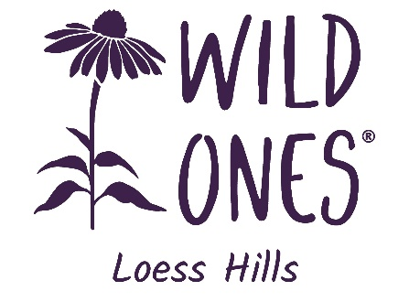

March 21, 2024

We appreciate your interest in applying for a Native Plant Grant from Loess Hills Wild Ones. We are excited by the possibility of helping you incorporate native plants into the Siouxland region!
This grant is intended to assist individuals with establishing or adding to an area of natural landscaping with native plants. Selected recipients will be awarded one flat (32 plants) from our 2024 Spring Native Plant Sale.
Please fill in the entire grant application to the best of your ability. The questions are designed to get you to think about and plan for all aspects of the project; the application is evaluated in its entirety. All grant applications are due by April 30, 2024.
If you have any questions, please get in touch with us at loesshillswildones@gmail.com and include the word “Grant” in the subject line.
Grants will be awarded on May 17, at 5:00 p.m., at our 2024 Spring Plant Sale at the home of our Co-Vice Presidents, Tom and Cheri Stewart, at 2801 S. Cecelia Street in Sioux City. We look forward to reviewing your application and are excited about the possibilities of more native plants in our area.

Sincerely,
Loess Hills Wild Ones

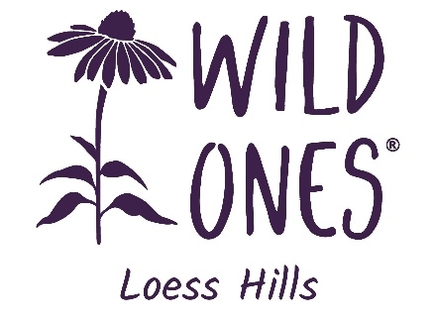
PLANT FLAT GRANT FOR INDIVIDUALS
Instructions
Complete this form, save it as a new file on your computer, and attach this file to an email as noted below.
- This grant is intended for anyone interested in planting native plants. Selected recipients will receive one flat of native plants from our 2024 Spring Native Plant Sale on May 17.
- Complete all sections of the Grant Application Form. These questions are designed to get individuals to think about and plan for all aspects of the project; the application is evaluated in its entirety.
- After completing this form, attach it to an email message addressed to loesshillswildones@gmail.com, noting “Grant Application” in the subject line. You can also print out a blank copy of the application, fill it in by hand, and mail it to the LHWO Grant Committee, 3301 Walden Ave., Sioux City, IA 51106.
- If you have any questions or need further information, please email loesshillswildones@gmail.com and include the word “Grant” in the subject line.
- All grant applications are due by April 30, 2024.

Are you a member of Loess Hills Wild Ones? Click or tap here to enter text.
Name of Person Requesting Grant: Click or tap here to enter text.
E‐mail Address: Click or tap here to enter text.
Street Address: Click or tap here to enter text.
City:  Click or tap here to enter text. |  | State:  Click or tap here to enter text. | Zip:  Click or tap here to enter text.
Phone:  Click or tap here to enter text. | Email:  Click or tap here to enter text.
Project Location:
Click or tap here to enter text.
Project Description
- Please briefly describe how your project will restore or develop the native plant community, provide habitat for native wildlife, and/or educate others about the beauty and significance of native ecosystems.
Click or tap here to enter text.
- Will the plants be used on your own property or somewhere else? If somewhere else, explain how the site will be maintained and who will be responsible for maintenance.
Click or tap here to enter text.
- What are your short- and long-term goals for the planting site?
Click or tap here to enter text.
- Describe the project location: What is the soil/ground like? How much sun does it get (hours/day, morning only, all day, etc.)? How moist does the soil get/remain after rain? What are the approximate dimensions?
Click or tap here to enter text.
- This grant program allows selected applicants to obtain one flat of plants from Loess Hills Wild Ones 2024 Spring Native Plant Sale. Please review the plants available from the sale and include a list of the plants you would choose if you are successfully awarded a grant. (Note: We understand that the plants listed may change.)
Agreement
• The Chapter shall have the right to supply others with a description and photos of the project and disseminate its underlying concepts and/or ideas.
• A representative of the Chapter will periodically observe your garden. We offer to mentor you and your new garden if desired.
• I will submit photos of the garden to the Chapter as able.
• The Chapter and sponsors and/or any of its agents, officials, and employees shall assume no responsibility or liability for claims of damage of any kind to property or claims of injury to any person in connection with a grant.

I agree to these terms and conditions: Click or tap here to enter text.

