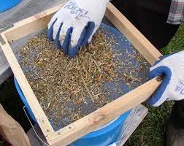
Loess Hills Wild Ones Seed Exchange
It’s Seed Exchange time for the Wild Ones this year-
And what a new kind it will be!
With Socially Distant outdoor space galore,
And masks on, for you and for me!

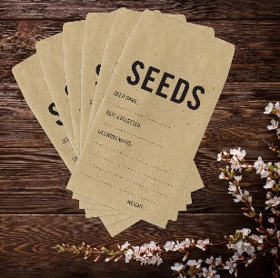
If you have some seeds that you’re willing to share,
Please Pre-Package them, on this we are firm!
Due to Covid we’re going to stay contact free this year-
We want to share seeds, -- but not germs!

We are hoping this year that the seeds we collect-
Will be Native, or Pollinator Friendly-
And if you have no seeds to share at this time-
We have plenty--and they’re all complimentary!

Please Save These Dates for the Fall Seed Exchange-
October 15^{th,} get the seeds ‘near’ our hands-
On October 18, we will meet at the park--
If you can’t, we have alternate plans!

We will meet at the Sertoma Shelter Outdoors,
4225 S Lancelot Lane-
In Sioux City, Iowa 51106-
The Shelter will protect us from rain!

How to make Free Seed Packets (3 ½ minutes).
Click on this video link for recycling junk mail or free template:
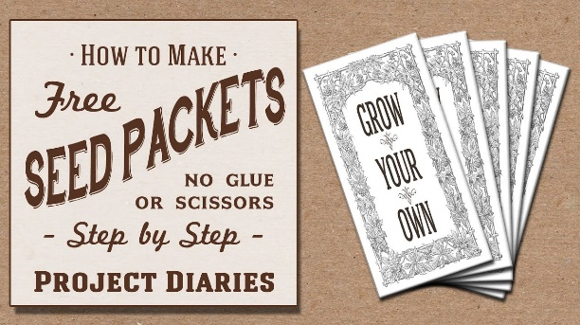
https://youtu.be/I183eqdMoqw

