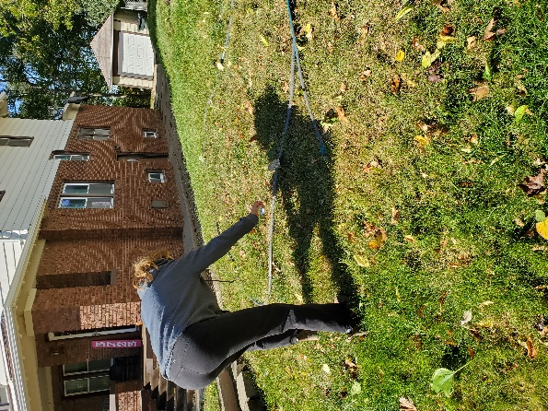
11No Dig Fall P re
o No Dig Fall/Winter Preparation for Spring Planting
1. Save and flatten cardboard boxes, removing the plastic tape.
2. Lay down a hose in the shape of the garden you prefer.
3. Either spray paint the shape around the hose, or leave the hose in place as you lay out cardboard.

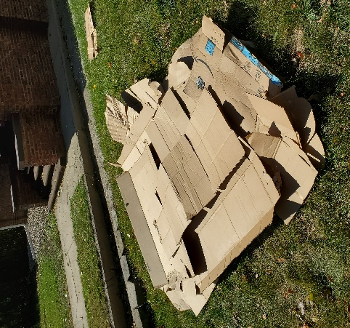
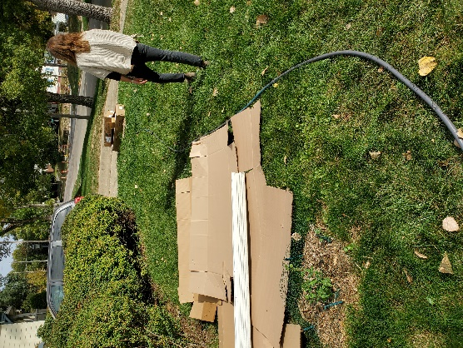

4. Lay out the cardboard, brown side up, inside the shape you created.

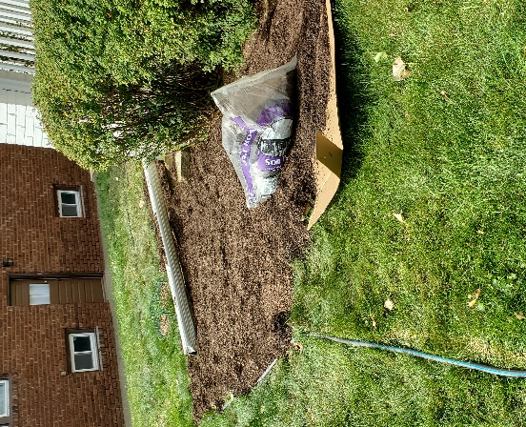
5. Cover 2-4 inches deep with mulch of your choice. Leaves, lawn clippings, wood chips, bark, whatever you prefer.
6. Edge- if you like- with any edging material of choice. Logs, bricks, concrete edgers, lawn edging with a shovel or-- anything!
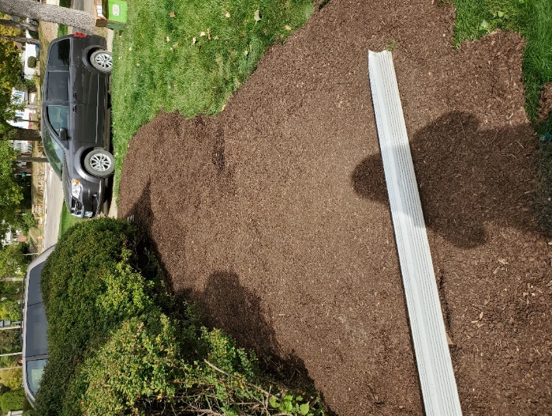
6. Add a bird bath, rock, or a piece of garden art if you choose. 7. Water thoroughly -if Nature is not doing this for you-- and wait until Spring to plant right THROUGH the cardboard. The cardboard acts a biodegradable weed barrier and turns the grass into natural compost in several weeks.

